**Problem Statement**: - Design an analytics framework to identify underperforming players in the Arizona Cardinals NFL team for potential trading, while sourcing high-performing players during the trading window.

**To understand the performance of an individual player based on the following 3 factors.**

1. Position experience
2. Performance ranking
3. Weather impact
4. Final ranking as per previous 3 factors

**Available data set.**

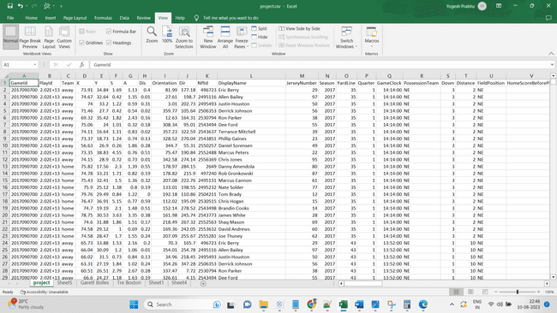

**Uploaded files on HDFS**

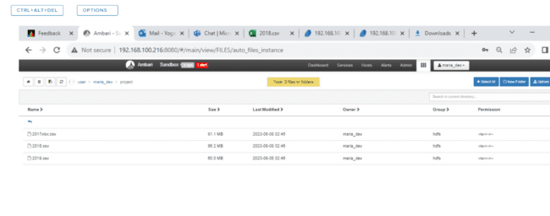

**Creating main data frame in zipline to perform the analysis**

* val d_2017 = (spark.read.option("header", "true").option("inferSchema", "true").csv("/user/maria_dev/project/2017xlsx.csv"))
* val d_2018 = (spark.read.option("header", "true").option("inferSchema", "true").csv("/user/maria_dev/project/2018.csv"))
* val d_2019 = (spark.read.option("header", "true").option("inferSchema", "true").csv("/user/maria_dev/project/2019.csv"))

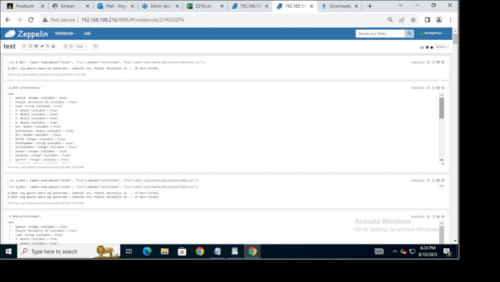

**Created data frames for separate files based on years**

* d_2017.createOrReplaceTempView("view_2017")
* d_2018.createOrReplaceTempView("view_2018")
* d_2019.createOrReplaceTempView("view_2019")
* val main_df = sqlContext.sql(" select * from view_2017 union

select * from view_2018 union

select * from view_2019")

* main_df.createOrReplaceTempView("main_df")
* select * from Main_df

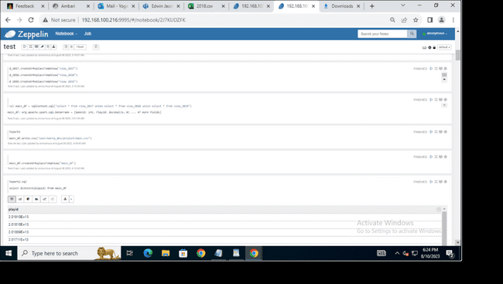

**Query to check first factor (Who played most on that particular position and ranked using window function).**

select

displayname,

position,number_1,

dense_rank () over ( order by number_1 desc ) as Rank_count

from   
(select

displayname,

position,

count(position) as number_1 from main_df

where season='2019' and HomeTeamabbr = 'ARI'

group by position,displayname

order by number_1 desc )

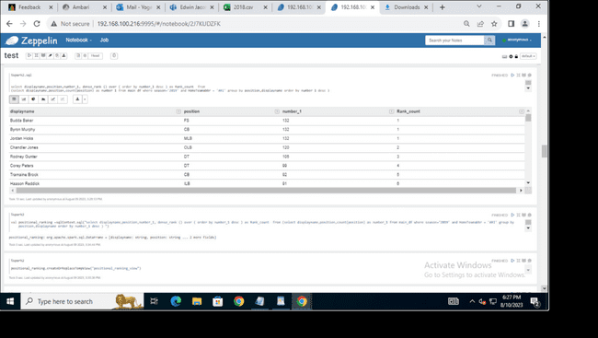

**Created a separate view for Positional ranking view**

* select * from positional_ranking_view

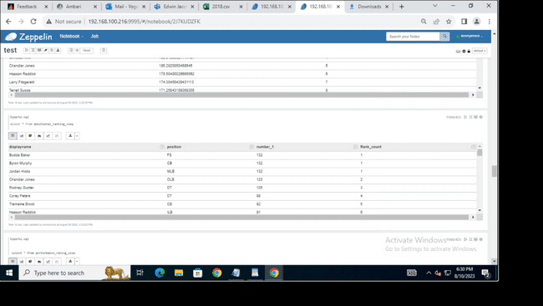

**Query to check second factor. (Performance ranking based on speed, acceleration, yards, and distance. Ranking them based on the performance index)**

select   
    displayname,  
    Performance_rating,  
    dense_rank () over (order by Performance_rating desc  ) as Rank_Performace from  
    (     
        select  
        displayname,  
        (NASpeed * 25 + NAAcceleration * 0.25 + NAdistance* 0.25 + 0.25*NAyards) AS Performance_rating  
        from   
            (select   
                displayname,  
                avg_speed- min_speed / max_speed- min_speed as NASpeed,  
                avg_accelaration- min_accelaration / max_accelaration- min_accelaration as NAAcceleration,  
                sum_distance- min_distance / max_distance- min_distance as NAdistance,  
                sum_yards- min_yards / max_yards- min_yards as NAyards  
            from   
                (SELECT   
                    displayname,  
                    avg(S) as avg_speed,  
                    min(s)  as min_speed,  
                    max(s)  as max_speed,  
                    avg(a) as avg_accelaration,  
                    min(a)  as min_accelaration,  
                    max(a)  as max_accelaration,  
                    sum(dis) as sum_distance,  
                    min(dis)  as min_distance,  
                    max(dis)  as max_distance,  
                    sum(yards) as sum_yards,  
                    min(yards)  as min_yards,  
                    max(yards)  as max_yards  
                FROM main_df  
                    where HomeTeamabbr = 'ARI' and   
                    season = '2019'     
                    group by displayname   
                    order by displayname  
                ) order by nayards desc  
            )

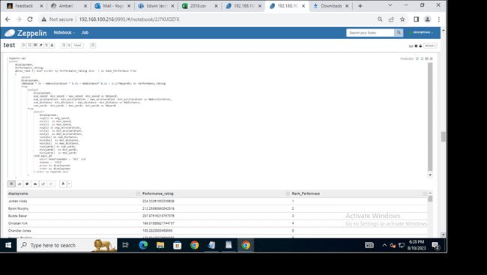

**Created a separate view for performance ranking**

* select * from performance_rating_view

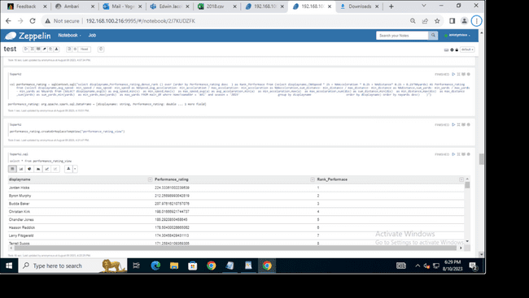

**Query to check second factor for player who are not in playing 11. (Performance ranking based on speed, acceleration, yards, and distance. Ranking them based on the performance index)**

select   
    displayname,  
    Performance_rating,  
    dense_rank () over (order by Performance_rating desc  ) as Rank_Performace from  
    (     
        select  
        displayname,  
        (NASpeed * 25 + NAAcceleration * 0.25 + NAdistance* 0.25 + 0.25*NAyards) AS Performance_rating  
        from   
            (select   
                displayname,  
                avg_speed- min_speed / max_speed- min_speed as NASpeed,  
                avg_accelaration- min_accelaration / max_accelaration- min_accelaration as NAAcceleration,  
                sum_distance- min_distance / max_distance- min_distance as NAdistance,  
                sum_yards- min_yards / max_yards- min_yards as NAyards  
            from   
                (SELECT   
                    displayname,  
                    avg(S) as avg_speed,  
                    min(s)  as min_speed,  
                    max(s)  as max_speed,  
                    avg(a) as avg_accelaration,  
                    min(a)  as min_accelaration,  
                    max(a)  as max_accelaration,  
                    sum(dis) as sum_distance,  
                    min(dis)  as min_distance,  
                    max(dis)  as max_distance,  
                    sum(yards) as sum_yards,  
                    min(yards)  as min_yards,  
                    max(yards)  as max_yards  
                FROM main_df  
                    where HomeTeamabbr <> 'ARI' and   
                    season = '2019'     
                    group by displayname   
                    order by displayname  
                ) order by nayards desc  
            )

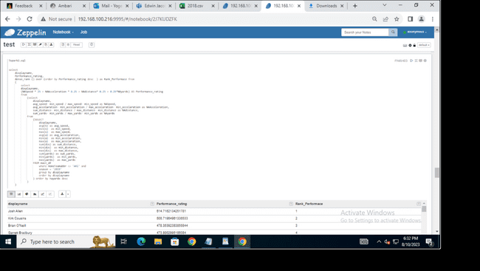

**Query to check performace ranking for player who are not in playing 11**

select * from performance_rating_not_ARI_View

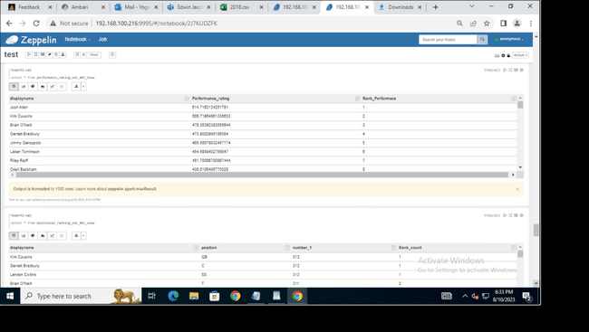

**Created a separate view of weather impact for player who are not in playing11.**

select

displayname,

weather_impact,

dense_rank() over(order by weather_impact desc ) as ranking_weather_impact

from

(Select displayname,

((avg_speed+(0.6*avg_temperature) +(0.2*avg_humidity)+(0.2*avg_windspeed))*0.5 +(avg_accelaration+(0.6*avg_temperature)+(0.2*avg_humidity)+(0.2*avg_windspeed))*0.5) as weather_impact

from (

SELECT

displayname,

avg(S) as avg_speed,

min(s) as min_speed,

max(s) as max_speed,

avg(a) as avg_accelaration,

min(a) as min_accelaration,

max(a) as max_accelaration,

ifnull(avg(temperature),68) as avg_temperature,

ifnull(avg(humidity),56) as avg_humidity,

ifnull(avg(windspeed),8) as avg_windspeed

FROM main_df

where HomeTeamabbr <> 'ARI' and season = '2019'

group by displayname

order by displayname

)

)

**Query to check the created view of performance ranking for players who are not in playing 11.**

select * from ranking_weather_impact_not_ari_view

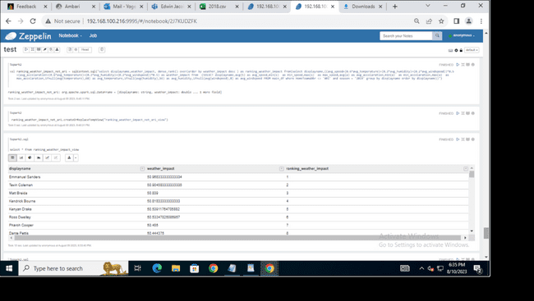

**Query to check overall rank if we consider all three factors Position ranking, performance ranking and weather impact on players who are playing11.**

select name,

final_rank,

dense_rank() over(order by final_rank )

from (select name,  
 (0.5 *a)+(0.45*b)+(0.05*c) as final_rank  
 from  
 (

select

posr.displayname as name,   
posr.rank_count as a,  
perr.rank_performace as b,  
ranw.ranking_weather_impact as c

from   
positional_ranking_view as posr,  
performance_rating_View as perr,   
ranking_weather_impact_view as ranw   
where   
posr.displayname=perr.displayname and   
perr.displayname=ranw.displayname

)  
 )

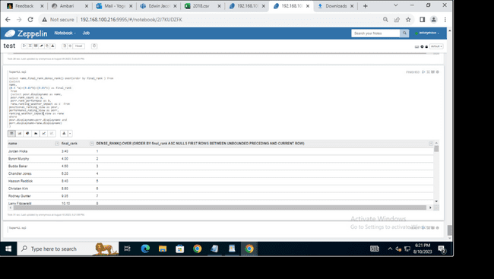

**Query to check overall rank if we consider all three factors Position ranking, performance ranking and weather impact on players who are not playing11.**

select name,

final_rank,

dense_rank() over(order by final_rank )

from (select name,

(0.5 *a)+(0.45*b)+(0.05*c) as final_rank

from (

select posr.displayname as name,

posr.rank_count as a,

perr.rank_performace as b,

ranw.ranking_weather_impact as c

from

positional_ranking_not_ari_view as posr,

performance_rating_not_ari_View as perr,

ranking_weather_impact_not_ari_view as ranw

where posr.displayname=perr.displayname and perr.displayname=ranw.displayname

) )